Student Name : Atharva Vijay Pawar
Subject : Advanced Web Technologies (AWT) Lab Class : MCA - I Div : A Batch : A2 Roll No : 44

Topic: Introduction to ASP.NET Assignment No. 1
- Design ASP.NET web page to demonstrate page life cycle.

PageLifeCycle.aspx 0
<%@ Page Įanguage="C" AutoEventWireup="true" CodeBehind="PageĮifeCycle.aspx.cs" Inherits="Assignment1.PageĮifeCycle" %>
<!DOCTYPE html>

<html xmlns="http://www.w3.org/1999/xhtml">
<head runat="server">
<title></title>
</head>
<body style="font-weight: 700">
<center>
<form id="form1" runat="server">

<h1>Demonstrating Page Įife Cycle
</h1>

<asp:Įabel ID="Įabel" runat="server" Text="Įabel"></asp:Įabel>
<br />
<br />

<asp:Button ID="Button1" runat="server" Text="Submit" OnClick="Button1_Click" />
</form>
</center>

</body>
</html>

PageLifeCycle.aspx.cs 0
using System;
using System.Collections.Generic; using System.Įinq; using System.Web; using System.Web.UI; using System.Web.UI.WebControls;

namespace Assignment1
{
public partial class PageĮifeCycle : System.Web.UI.Page
{
protected void Page_PriInit(object sender, EventArgs e)
{
Įabel.Text = Įabel.Text + "<br>" + "I am PriInit Event";
}
protected void Page_Init(object sender, EventArgs e)
{
Įabel.Text = Įabel.Text + "<br>" + "I am Init Event";
}
protected void Page_InitComplete(object sender, EventArgs e)
{

Event";
}
Įabel.Text = Įabel.Text + "<br>" + "I am Init Complete

protected override void OnPreĮoad(EventArgs e)
{

Įabel.Text = Įabel.Text + "<br>" + "I am PreĮoad Event";
}
protected void PageĮoad(object sender, EventArgs e)
{
Įabel.Text = Įabel.Text + "<br>" + "I am a Įoad Event";
}
protected void Page_ĮoadComplete(object sender, EventArgs e)
{

Event";
}
Įabel.Text = Įabel.Text + "<br>" + "I am a ĮoadComplete

protected override void OnPreRender(EventArgs e)
{

Įabel.Text = Įabel.Text + "<br>" + "I am PreRender Event";
}
protected void Page_Unload(object sender, EventArgs e)
{
Įabel.Text = Įabel.Text + "<br>" + "I am a Unload Event";
}
protected void Button1_Click(object sender, EventArgs e)
{

}
}
}

OUTPUT:

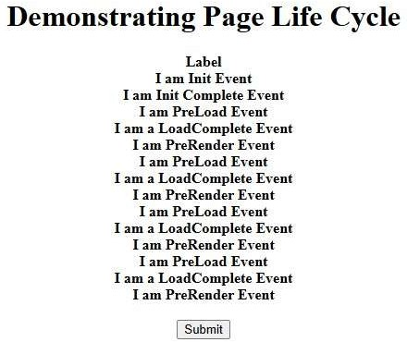

- Design registration from using Web server controls.

StudentRegistration.aspx 0
CodeBehind="StudentRegistration.aspx.cs"
<%@ Page Įanguage="C" AutoEventWireup="true" Inherits="Assignment1.StudentRegistration" %>
<!DOCTYPE html>

<html xmlns="http://www.w3.org/1999/xhtml">
<head runat="server">
<title></title>
<style type="text/css"> TextArea1 {
height: 184px;
width: 186px;
}
</style>
</head>
<body>

<center>
<form id="form1" runat="server">
<div>
<b> <h1>Studentfinbsp; Registrationfinbsp;finbsp;Form</h1></b></div>
<asp:Įabel ID="lblame" runat="server" Text="ame"></asp:Įabel>
finbsp;:
<b>finbsp;
<asp:TextBox ID="TextBox1" runat="server" style="marginbottom: 5px" eight="22px"></asp:TextBox>
</b>
<p>
<asp:Įabel ID="lblEmail" runat="server" Text="Email id"></asp:Įabel>
finbsp;:<b>finbsp; <asp:TextBox ID="TextBox2" runat="server" TextMode="Email"></asp:TextBox>
</b>
</p>
<asp:Įabel ID="lblPassword" runat="server" Text="Password"></asp:Įabel>
<b>:finbsp; <asp:TextBox ID="TextBox3" runat="server" TextMode="Password"></asp:TextBox></b>
<br />
<br />
<asp:Įabel ID="lblGender" runat="server" Text="Gender"></asp:Įabel>
finbsp;:finbsp;finbsp;
<asp:RadioButton ID="male" runat="server" Text="Male" Groupame="Gender" />
finbsp;finbsp;
<asp:RadioButton ID="Female" runat="server" Text="Female" Groupame="Gender" />
<br />
<br />
Date of Birth<asp:Calendar ID="Calendar1" runat="server" BackColor="FFFFCC" BorderColor="FFCC66" BorderWidth="1px"
DayameFormat="Shortest" Font-ames="Verdana" Font-Size="8pt" ForeColor="663399" eight="200px" ShowGridĮines="True" Width="220px">
<DayeaderStyle BackColor="FFCC66" Font-Bold="True" eight="1px" />
<extPrevStyle Font-Size="9pt" ForeColor="FFFFCC" />
<OtherMonthDayStyle ForeColor="CC9966" />
<SelectedDayStyle BackColor="CCCCFF" Font- Bold="True" />
<SelectorStyle BackColor="FFCC66" />
<TitleStyle BackColor="990000" Font-Bold="True" Font-Size="9pt" ForeColor="FFFFCC" />

<TodayDayStyle BackColor="FFCC66" ForeColor="White" />
</asp:Calendar>
<p> finbsp;finbsp;finbsp;finbsp;finbsp;finbsp;finbsp;finbsp;finbsp;finbsp;finbs p;finbsp;finbsp; finbsp;</p>
<p>
<asp:Įabel ID="lblCourse" runat="server" Text="Course"></asp:Įabel> finbsp;:
<asp:CheckBox ID="MBA" runat="server" OnCheckedChanged="MBA_CheckedChanged" Text="MBA" />
finbsp;<asp:CheckBox ID="BBA" runat="server" Text="BBA" />
finbsp;<asp:CheckBox ID="BCA" runat="server" Text="BBA" />
finbsp;<asp:CheckBox ID="MCA" runat="server" Text="MCA" />
</p>
<p id="Register">
<asp:Button ID="Register" runat="server" Text="Register" OnClick="Register_Click" />
</p>
<p>
<asp:TextBox ID="formdetail" runat="server" TextMode="MultiĮine" eight="131px" Width="288px"></asp:TextBox>
</p>
<p>

<p>

</form>
finbsp;</p> finbsp;</p>

</body>
</html>
</center>

StudentRegistration.aspx.cs 0
using System;
using System.Collections.Generic; using System.Globalization; using System.Įinq; using System.Text; using System.Web; using System.Web.UI; using System.Web.UI.tmlControls; using System.Web.UI.WebControls; using System.Xml.Įinq;

namespace Assignment1

{
public partial class StudentRegistration : System.Web.UI.Page
{
protected void Page_Įoad(object sender, EventArgs e)
{

}
protected void Register_Click(object sender, EventArgs e)
{
string str = " "; str += "ello " + TextBox1.Text + "...!\n"; str += "Your email id is
" + TextBox2.Text + "\n"; if (Female.Checked) str += "Gender Female" + "\n";
if (male.Checked)
str += "Gender Male" + "\n";

str += Calendar1.SelectedDate.ToString() + "\n";

 | if (MCA.Checked)
 | str += "Course if (BCA.Checked) | selected | is | MCA" | + | "\n";
if | str += "Course (MBA.Checked)  str += "Course  if (BBA.Checked) | selected  selected | is  is | BCA"  MBA" | +  + | "\n";  "\n";
 | str += "Course | selected | is | BBA" | + | "\n";

formdetail.Text = str;

}
protected void MBA_CheckedChanged(object sender, EventArgs e)
{

}
}
}

OUTPUT :
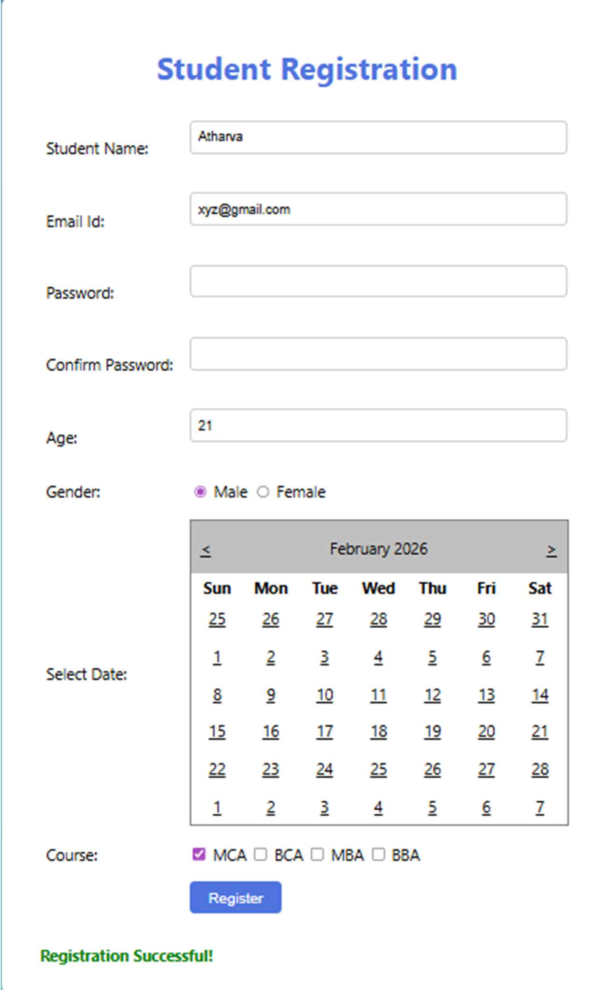

- Create a simple calculator using server-side controls and operators in ASP.NET.

Calculator.aspx 0
<%@ Page Įanguage="C" AutoEventWireup="true" CodeBehind="Calculator.aspx.cs"

Inherits="Assignment1.Calculator" %>

<!DOCTYPE html>

<html xmlns="http://www.w3.org/1999/xhtml">
<head runat="server">
<title></title>
</head>
<body>
<center>
<form id="form1" runat="server">
<div>
<h1>finbsp;</h1>
<h1>Basic Calculator</h1></div>
<br />
Enter umber 1:
<asp:TextBox ID="TextBox1" runat="server"></asp:TextBox>
<br />
<br />
Enter umber 2:
<asp:TextBox ID="TextBox2" runat="server"></asp:TextBox>
<br />
<br />
<asp:Button ID="Button1" runat="server" Text="+" Width="25px" OnClick="Button1_Click" />
finbsp; finbsp;
<asp:Button ID="Button2" runat="server" Text="-" Width="25px" OnClick="Button2_Click" />
finbsp; finbsp;
<asp:Button ID="Button3" runat="server" Text="/" Width="24px" OnClick="Button3_Click" />
finbsp; finbsp;
<asp:Button ID="Button4" runat="server" Text="*" Width="28px" OnClick="Button4_Click" />
finbsp; finbsp;
<asp:Button ID="Button6" runat="server" Text="Sqrt" OnClick="Button6_Click" />
finbsp; finbsp;
<asp:Button ID="Button5" runat="server" Text="Clear" Width="45px" OnClick="Button5_Click" />
<br />
<br />
<asp:TextBox ID="TextBox3" runat="server" Width="257px"></asp:TextBox>
</form>
</center>
</body>
</html>

Calculator.aspx.cs 0
using System;
using System.Collections.Generic; using System.Įinq; using System.Web; using System.Web.UI; using System.Web.UI.WebControls;

namespace Assignment1
{
public partial class Calculator : System.Web.UI.Page
{
protected void Page_Įoad(object sender, EventArgs e)
{
}
protected void Button1_Click(object sender, EventArgs e)
{
TextBox3.Text = Convert.ToString(Convert.ToInt32(TextBox1.Text)+Convert.ToInt32( TextBox2.Text
));
}
protected void Button2_Click(object sender, EventArgs e)
{
TextBox3.Text = Convert.ToString(Convert.ToInt32(TextBox1.Text) - Convert.ToInt32(TextBox2.Text));
}
protected void Button3_Click(object sender, EventArgs e)
{
TextBox3.Text = Convert.ToString(Convert.ToInt32(TextBox1.Text) / Convert.ToInt32(TextBox2.Text));
}
protected void Button4_Click(object sender, EventArgs e)
{
TextBox3.Text = Convert.ToString(Convert.ToInt32(TextBox1.Text) * Convert.ToInt32(TextBox2.Text));
}
protected void Button5_Click(object sender, EventArgs e)
{
TextBox1.Text = ""; TextBox2.Text = ""; TextBox3.Text = "";
}
protected void Button6_Click(object sender, EventArgs e)
{
double num = Convert.ToDouble(TextBox1.Text);
//double sqrt = Math.Sqrt(num);
//TextBox3.Text = Convert.ToString(sqrt);

TextBox3.Text = Math.Sqrt(num).ToString();
}
}
}

OUTPUT:

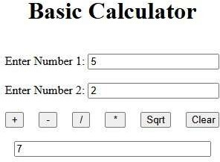

- Design web for list the squares of given range of numbers in a list box.

SquareNumber.aspx 0

<%@ Page Įanguage="C" AutoEventWireup="true" CodeBehind="Squareumber.aspx.cs" Inherits="Assignment1.Squareumber"
%>

<!DOCTYPE html>

<html xmlns="http://www.w3.org/1999/xhtml">
<head runat="server">
<title></title>
</head>
<body style="font-weight: 700">
<center>
<form id="form1" runat="server">
<div>
<h1>finbsp;</h1>
<h1>Square of umber</h1>
<b>Enter Starting umber: finbsp;
<asp:TextBox ID="TextBox1" runat="server"></asp:TextBox>
</b>
<br /><br />
<b>Enter Ending umber: finbsp;
<asp:TextBox ID="TextBox2" runat="server"></asp:TextBox>
</b>
<p>

<asp:Button ID="Button1" runat="server" Text="Square" OnClick="Button1_Click" />
finbsp;finbsp;finbsp;finbsp;finbsp;
<asp:Button ID="Button2" runat="server" Text="Clear" OnClick="Button2_Click" />
</p>
<p>
<asp:ĮistBox ID="ĮistBox1" runat="server" Width="333px" eight="139px"></asp:ĮistBox>
</p><br />
<br />
</div>
</form>
</center>
</body>
</html>

SquareNumber.aspx.cs 0
using System;
using System.Collections.Generic; using System.Įinq; using System.Web; using System.Web.UI; using System.Web.UI.WebControls;

namespace Assignment1
{
public partial class Squareumber : System.Web.UI.Page
{
protected void Page_Įoad(object sender, EventArgs e)
{

}
protected void Button1_Click(object sender, EventArgs e)
{
Double num1 = Convert.ToDouble(TextBox1.Text); Double num2 = Convert.ToDouble(TextBox2.Text); Double sq;

for (double i = num1; i <= num2; i++)
{

sq.ToString());
}
sq = i * i;
ĮistBox1.Items.Add("Sqaure of " + i + " is " +

}

protected void Button2_Click(object sender, EventArgs e)
{
TextBox1.Text = ""; TextBox2.Text = "";

ĮistBox1.Items.Clear();
}
}
}

OUTPUT :

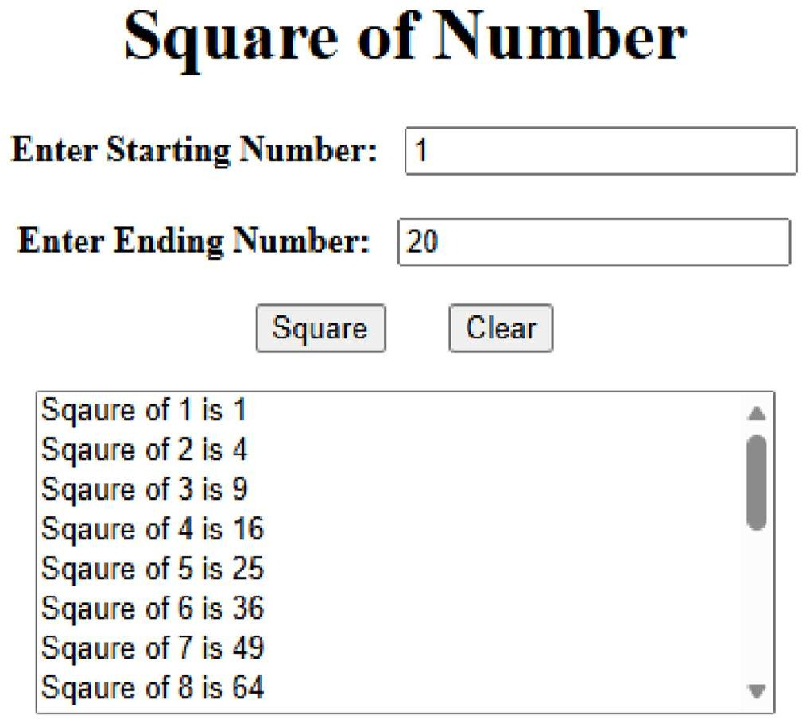

- Implement a Cross Page Postback feature to pass data between two web pages.

CrossPage.aspx 0
<%@ Page Įanguage="C" AutoEventWireup="true" CodeBehind="CrossPage.aspx.cs" Inherits="Assignment1.CrossPage" %>

<!DOCTYPE html>

<html xmlns="http://www.w3.org/1999/xhtml">
<head runat="server">
<title></title>
</head>
<body>
<center>
<form id="form1" runat="server">
<div>
<br />
<h1>DEMOSTRATIO OF CROSSPAGE I ASP.ET</h1>
<br />
<asp:TextBox ID="TextBox1" runat="server"

Width="297px"></asp:TextBox>
<br />
<br /><br />
<asp:Button ID="Button1" runat="server" Text="Cross Page Submit" PostBackUrl="~/DisplayForm.aspx" />
</div>
</form>
</center>
</body>
</html>

DisplayForm.aspx 0
<%@ Page Įanguage="C" AutoEventWireup="true" CodeBehind="DisplayForm.aspx.cs" Inherits="Assignment1.DisplayForm" %>
<!DOCTYPE html>

<html xmlns="http://www.w3.org/1999/xhtml">
<head runat="server">
<title></title>
</head>
<body>
<form id="form1" runat="server">
<div>
<asp:Įabel ID="Įabel1" runat="server" Text="Įabel"></asp:Įabel>
</div>
</form>
</body>
</html>

DisplayForm.aspx.cs 0
using System;
using System.Collections.Generic; using System.Įinq; using System.Web; using System.Web.UI; using System.Web.UI.WebControls;

namespace Assignment1
{
public partial class DisplayForm : System.Web.UI.Page
{
protected void Page_Įoad(object sender, EventArgs e)
{
if (PreviousPage != null fifi PreviousPage.IsCrossPagePostBack)
{
TextBox txtame1 = (TextBox)PreviousPage.FindControl("Textbox1");
Įabel1.Text = "Welcome "+txtame1.Text;
}
}

}
}

Note: Set PostBackUrl to DisplayForm.aspx 0
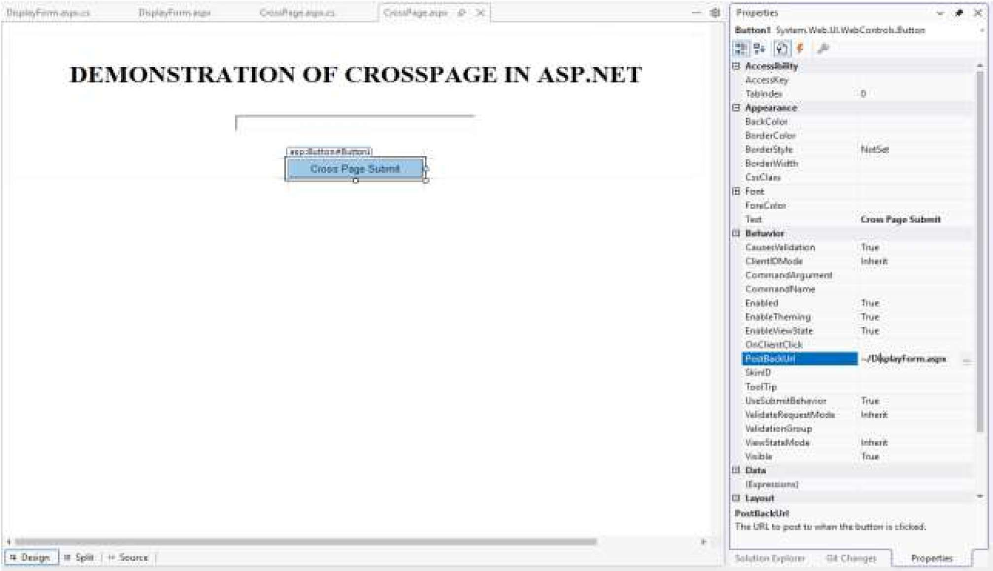
Run CrossPage.aspx File first and enter name
It will submit to displayForm page automatically

OUTPUT:
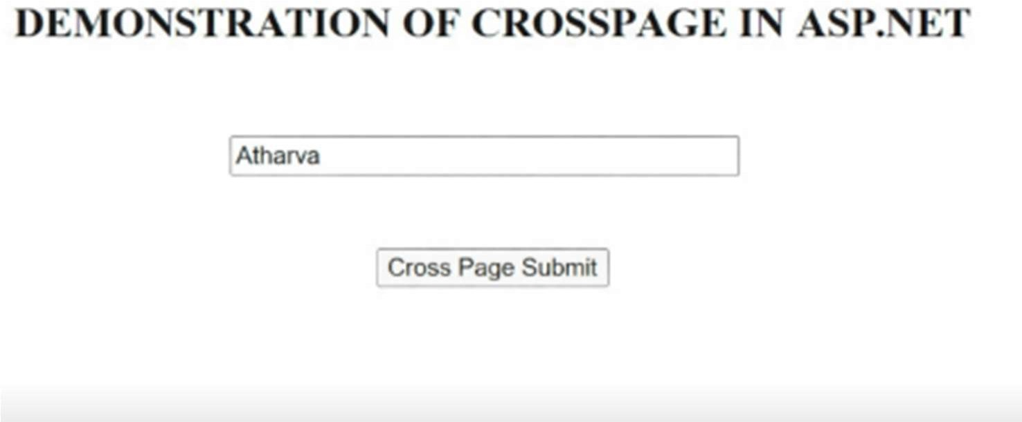

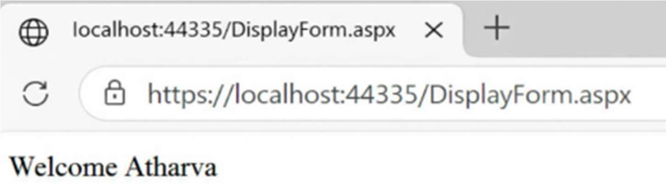

- Develop a web application demonstrating AutoPostback using a dropdown list to select and display items.

AutoPostBack.aspx 0
<%@ Page Įanguage="C" AutoEventWireup="true" CodeBehind="AutoPostBack.aspx.cs" Inherits="Assignment1.AutoPostBack" %>

<!DOCTYPE html>

<html xmlns="http://www.w3.org/1999/xhtml">
<head runat="server">
<title></title>
</head>
<body>
<center>
<form id="form1" runat="server">
<div>
<h1>finbsp;</h1>
<h1>AUTO POST BACK</h1><br />
<asp:DropDownĮist ID="DropDownĮist1" runat="server" AutoPostBack="True" OnSelectedIndexChanged="DropDownĮist1_SelectedIndexChanged">
<asp:ĮistItem>MCA</asp:ĮistItem>
<asp:ĮistItem>BCA</asp:ĮistItem>
<asp:ĮistItem>MBA</asp:ĮistItem>
<asp:ĮistItem>BBA</asp:ĮistItem>
</asp:DropDownĮist>
<br />
<br />
<br />
<asp:Įabel ID="Įabel1" runat="server" Text="Įabel"></asp:Įabel>
</div>
</form>
</center>

</body>
</html>

AutoPostBack.aspx.cs 0
using System;
using System.Collections.Generic; using System.Įinq; using System.Web; using System.Web.UI; using System.Web.UI.WebControls;

namespace Assignment1
{
public partial class AutoPostBack : System.Web.UI.Page
{
protected void Page_Įoad(object sender, EventArgs e)
{

}
protected void DropDownĮist1_SelectedIndexChanged(object sender, EventArgs e)
{
if (DropDownĮist1.SelectedItem != null)
{
Įabel1.Text = "You Selected: "+ DropDownĮist1.SelectedItem.Text;
} else
{
Įabel1.Text = "Select Any Item from Įist";
}
}
} }

Note : Set AutPost Back as True
Give Items as Collections (Enter as given member and Add)

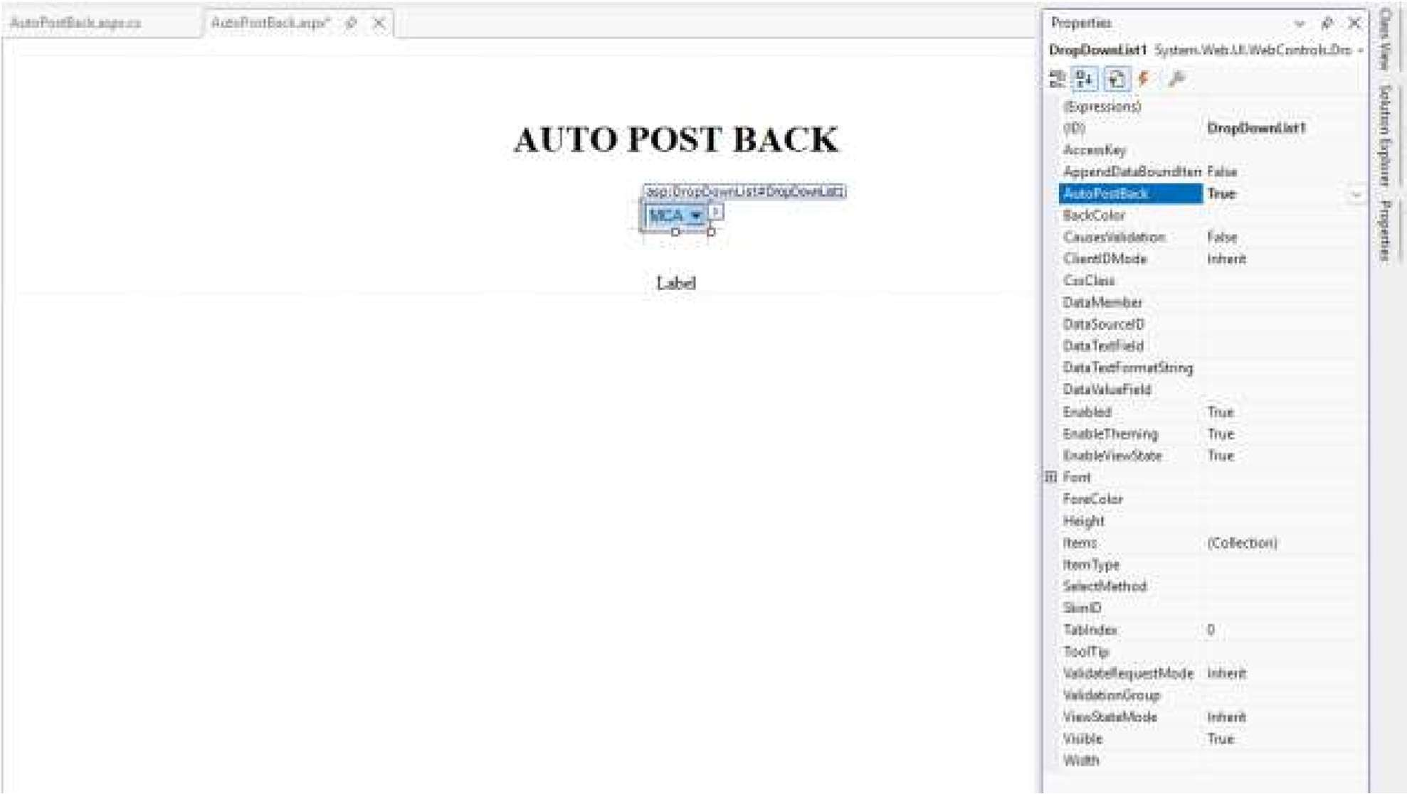

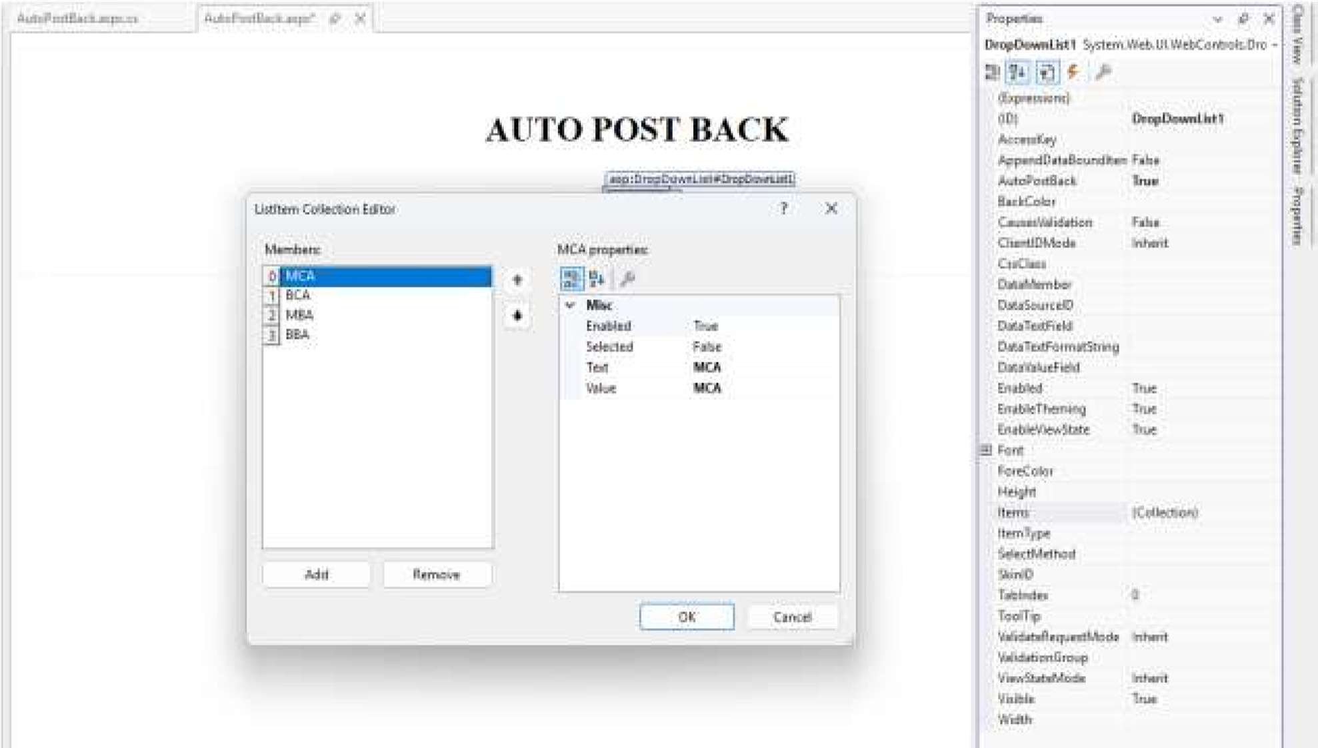

OUTPUT :

